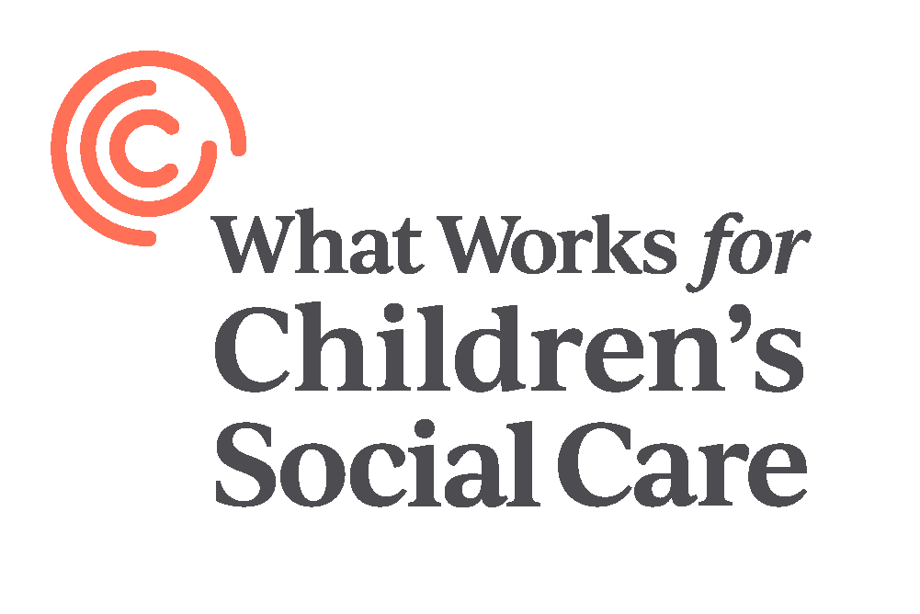

Assistant Programmes Manager

Candidate Brief

Dear Candidate,

Thank you for your interest in the Assistant Programmes Manager role at What Works for Children’s Social Care.

What Works for Children’s Social Care (WWCSC) is an exciting ‘social start-up’ and a fantastic opportunity to make a difference to the lives of children and their families in England. Every year over 700,000 children and young people, and their families, have contact with the children’s social care sector. Changes in how the sector supports these children and their families can have hugely significant effects that resonate throughout entire lifetimes.

The Government’s reform programme is increasingly giving control over how services should be run – along with accountability for the results – to the practitioners and practice leaders who are closest to children, young people and their families. Local authorities up-and-down the country, and supported by a range of other organisations both statutory and third sector, are using that freedom to try different ways of designing and delivering children’s services, and up to £200m is being provided through the Department for Education’s Innovation Programme to support this work.

With so much innovation taking place – and so much potential for change – the sector needs an independent organisation to look across all of this work and systematically develop the evidence base on what works, for whom, under what circumstances, and how. This is the best encapsulation of WWCSC’s mission – to collect the best evidence on what we already know, work with the sector to prioritise the many questions that remain unanswered, fund research, and determine how best to make evidence relevant and accessible to decision makers. What Works Centres have been a great success in other policy areas – including in education, policing and healthcare – and we expect great things from What Works for Children’s Social Care, which will be a fully-financed and independent body by March 2020.

Reporting to the Centre’s Programmes Manager, the post holder will support on all aspects of the grant funding and commissioning process.

I look forward to hearing from you.

Michael Sanders
Executive Director, What Works Centre for Children’s Social Care

The team
The Programmes team at What Works for Children’s Social Care is responsible for the grant funding and commissioning, the team strives to:
- Raise the standards - and volume - of good quality research in the sector, by maintaining a core focus on rigorous research, providing appropriate support, and by leading by example in the work that we fund.
- Encourage sector-led innovation and research in key priority areas identified by the Centre.
- Attract experts and influential organisations from other sectors to children’s social care research, to broaden expertise in the sector and create opportunities for collaboration.

We aim to do this by using funding as a mechanism to support the creation of new research, a lever by which to influence the standard and priorities of research in the sector, and an incentive to others (individuals and organisations) to shift resources towards children’s social care research. Our approach is broadly divided into two complementary strands: funding of projects (supporting organisations to deliver their interventions), and funding of evaluations (supporting researchers to determine the impact of these interventions on outcomes of interest).

The role
Programme management:
- Supporting the delivery of programmes, including working closely with external stakeholders to monitor performance against milestones and deliverables.
- Supporting internal project teams on programme management including planning, partner management, monitoring, and reporting.
- Working closely with members of the research team to ensure that their input is sought to assess methodological plans and to resolve methodological issues in a timely manner.
- Monitoring programme specific budgets.
Funding processes
- Supporting the set-up of new funding programmes including; implementation of reporting structures, development of funding processes and guidance.
- Assessment of applications, including grantee and project due diligence.
- Supporting funding processes including managing peer review and panel preparation.
- Maintaining databases and grant-making information.
- Contributing to the continuous improvement of guidance, decision-making and grant management processes.

The Person
- Personal commitment to improving outcomes for children and young people, and their families.
- A passion for the agenda around What Works Centres and the broader agenda around evidence-based policy and practice in public services.
- Able to work flexibly and adapt to shifting priorities.
- Confident working independently and as part of a small team.
Knowledge and Experience:
- Experience of programme or research management (E)
- Experience of commissioning and grant/contract management. (D)
- Knowledge of barriers to research in children’s social care. (D)
- Familiarity with randomised controlled trials and other evaluation methodologies. (D)
- Experience of working in a fast-paced environment. (E)
Skills and Abilities:
- Ability to work effectively with a wide range of partner organisations
- Ability to prioritise competing demands
- Ability to work well as a team
- Highly organised and good attention to detail

Initial Terms and Conditions of Appointment
What Works for Children’s Social Care is looking to recruit an Assistant Programmes Manager to work as part of a small but growing team, to support the delivery of existing programmes and the competitive funding of new research.
- Remuneration: £30-38k
- Time Commitment: Full time role (37.5 hours per week)
- Location: Central London. Travel around England may be required occasionally
- Term: Permanent
- Other:
o Reports to the Programmes Manager

Introduction to the Centre
About Us
What Works for Children’s Social Care seeks better outcomes for children, young people and families by bringing the best available evidence to practitioners and other decision makers across the children’s social care sector. We generate, collate and make accessible the best evidence for practitioners, policy makers and practice leaders to improve children’s social care and the outcomes it generates for children and families.
Our research looks at the point of referral through to permanence, including adoption, care-leaver support and targeted early help. We focus on children’s social care practice in England and draw on and share learning at the international level.
We were commissioned by the Department for Education and work with a range of stakeholders. Engagement and co-design are central to our approach and we are working in close consultation with leaders, practitioners, children and young people, families and researchers across the sector to:
- Identify gaps in the evidence, and create new evidence through trials and evaluations
- Collate, synthesise and review existing evidence
- Develop, test and publish tools and services that support the greater use of evidence and inform the design of the future Centre
- Champion the application of robust standards of evidence in children’s social care research.
WWCSC collates, produces, and translates research about “What Works” in Children’s Social Care through a variety of different methodologies, both qualitative and quantitative, to conduct research that can be used by social workers, leaders in the sector and policymakers to support children and their families.
To do this, all of our research needs to adhere to our four principles:
- Research needs to focus on impact – how does a piece of practice work, how does it impact on social workers, and if we take one action rather than another, what happens as a result?
- We need to bear in mind the nuance of social care. The lives of children and families are complex and complicated, and there are many factors involved in successful social work. What works in one setting for one family might not work in a different circumstance. We need to design our research to take into account – and even celebrate – this complexity.
- Studies have to be useful – if we can’t identify who we think should be able to make use of a piece of research, it’s not for us. While there is certainly value in more exploratory research, this is not part of the Centre’s mission and objectives.
- Everything we do needs to help empower the profession. Our research needs to be conducted with the profession, and not done to them – it needs to provide recommendations, not prescriptions, and it needs to support existing and innovative practice to grow the evidence base.
How to apply

To apply, please send your CV and a supporting statement outlining clearly how meet the above criteria to hr@whatworks-csc.org.uk, citing “Assistant Programmes Manager” in the subject of the email.

Deadline for applications: 5pm 19th August 2020

