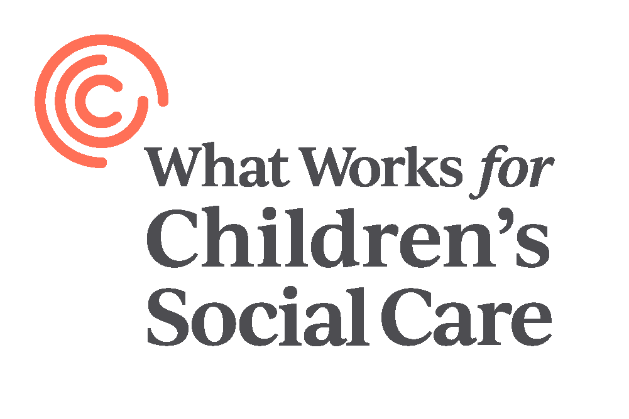

**Research Director**

**Candidate Brief**

Dear Candidate,

Thank you for your interest in the Research Director role at What Works for Children’s Social Care.

What Works for Children’s Social Care (WWCSC) is an exciting ‘social start-up’ and a fantastic opportunity to make a difference to the lives of children and their families in England. Every year over 700,000 children and young people, and their families, have contact with the children’s social care sector. Changes in how the sector supports these children and their families can have hugely significant effects that resonate throughout entire lifetimes.

The Government’s reform programme is increasingly giving control over how services should be run – along with accountability for the results – to the practitioners and practice leaders who are closest to children, young people and their families. Local authorities up-and-down the country, and supported by a range of other organisations both statutory and third sector, are using that freedom to try different ways of designing and delivering children’s services, and up to £200m is being provided through the Department for Education’s Innovation Programme to support this work.

With so much innovation taking place – and so much potential for change – the sector needs an independent organisation to look across all of this work and systematically develop the evidence base on what works, for whom, under what circumstances, and how. This is the best encapsulation of WWCSC’s mission – to collect the best evidence on what we already know, work with the sector to prioritise the many questions that remain unanswered, fund research, and determine how best to make evidence relevant and accessible to decision makers. What Works Centres have been a great success in other policy areas – including in education, policing and healthcare – and we expect great things from What Works for Children’s Social Care, which is a fully-financed and independent chairty.

The What Works for Children’s Social Care is looking to recruit a Research Director to lead our research team. The team will lead the centre’s analytical work, which covers research relating to a wide variety of outcomes for young people and their families, as well as of the social care system itself. This includes the design and conducting of randomised controlled trials of national programmes, a programme of work to improve the health and wellbeing of social workers, and analysis of national and local datasets to understand the needs of young people and their families. We would also expect the Research Director to lead the development of new research priorities and programmes related to children’s social care.

This role will work closely with the Chief Executive and the rest of the centre’s management team, as well as with external stakeholders, to ensure the success of the centre’s ambitious research agenda.

I look forward to hearing from you.

**Michael Sanders**

Chief Executive, What Works for Children’s Social Care

**The role**

**Research Leadership**

The centre will be completing research programmes in organisational behaviour, data analysis, randomised controlled trial design and piloting, and machine learning in early 2020. This role will lead these programmes of work, their dissemination and ensuring their impact.

The Research Director will work with the Executive Director to shape the strategic priorities for the research team into the next year and beyond, and to build, develop and deploy the research team to meet those strategic objectives.

**Subject expertise**

The Research Director will lead our programme of work to understand how best to support social workers and young people in contact with children’s services, from the point of contact and referral, all the way through to foster care and adoption. The research director will need understanding of the national and local context of children’s social care, and have conducted research involving vulnerable young people previously.

**Collaboration and partnerships**

The Research Director will work with the Programmes Director to support research projects being conducted in partnership with other research organisations, including collaborators, and other organisations that have been commissioned by What Works for Children’s Social Care. They will also work closely with the sector and with officials at the Department for Education to ensure that the centre’s research priorities and outputs align with the interests of practitioners and policymakers on the ground.

**Standard setting**

The Research Director will work closely with the existing research team and the centre’s leadership to produce analytical and evaluation guidance that ensures the rigour of and research conducted and commissioned by the centre, while being flexible enough to allow that evidence to be produced in the complex environment of children’s social care.

**Line management;**

The role will lead the research team within the centre, ensuring the delivery of work on time and to a high standard.

**Essential**

* Experience in conducting randomised controlled trials and other impact evaluations.
* A high level of competence in Stata or R
* Experiencing conducting or overseeing qualitative pilot research
* A solid understanding of analytical and research issues in children’s social care
* Experience conducting quantitative evaluations, either experimental or quasi-experimental, in children’s social care or with vulnerable young people.
* Ability to work at a fast pace and to tight deadlines where appropriate
* Line management experience

**Initial Terms and Conditions of Appointment**

* **Remuneration**: £60,000-75,000 pa
* **Time Commitment**: Full time role (37.5 hours per week)
* **Location:** Central London.

**Introduction to the Centre**

**About Us**

What Works for Children’s Social Care seeks better outcomes for children, young people and families by bringing the best available evidence to practitioners and other decision makers across the children’s social care sector. We generate, collate and make accessible the best evidence for practitioners, policy makers and practice leaders to improve children’s social care and the outcomes it generates for children and families.

Our research looks at the point of referral through to permanence, including adoption, care-leaver support and targeted early help. We focus on children’s social care practice in England and draw on and share learning at the international level.

We were commissioned by the Department for Education and work with a range of stakeholders. Engagement and co-design are central to our approach and we are working in close consultation with leaders, practitioners, children and young people, families and researchers across the sector to:

* Identify gaps in the evidence, and create new evidence through trials and evaluations
* Collate, synthesise and review existing evidence
* Develop, test and publish tools and services that support the greater use of evidence and inform the design of the future Centre
* Champion the application of robust standards of evidence in children’s social care research.

WWCSC collates, produces, and translates research about “What Works” in Children’s Social Care through a variety of different methodologies, both qualitative and quantitative, to conduct research that can be used by social workers, leaders in the sector and policymakers to support children and their families.

To do this, all of our research needs to adhere to our four principles:

* Research needs to focus on impact – how does a piece of practice work, how does it impact on social workers, and if we take one action rather than another, what happens as a result?
* We need to bear in mind the nuance of social care. The lives of children and families are complex and complicated, and there are many factors involved in successful social work. What works in one setting for one family might not work in a different circumstance. We need to design our research to take into account – and even celebrate – this complexity.
* Studies have to be useful – if we can’t identify who we think should be able to make use of a piece of research, it’s not for us. While there is certainly value in more exploratory research, this is not part of the Centre’s mission and objectives.
* Everything we do needs to help empower the profession. Our research needs to be conducted with the profession, and not done to them – it needs to provide recommendations, not prescriptions, and it needs to support existing and innovative practice to grow the evidence base.

**How to apply**

To apply, please send your CV and a supporting statement outlining clearly how meet the above criteria to info@whatworks-csc.org.uk, citing “Director of Research” in the Subject of the email.

**Deadline for applications: 12pm 27th April 2020**